Analyzing and plotting the given data:
Given the files provided: agency.txt, stops.txt, routes.txt, trips.txt, stop_times.txt, calendar.txt, calendar_dates.txt and feed_info.txt
First, we need to check their contents and make them available in python with the helper: gtfs_loader.py
That loads all relevant GTFS tables into memory and exposes them as clean Python data structures.
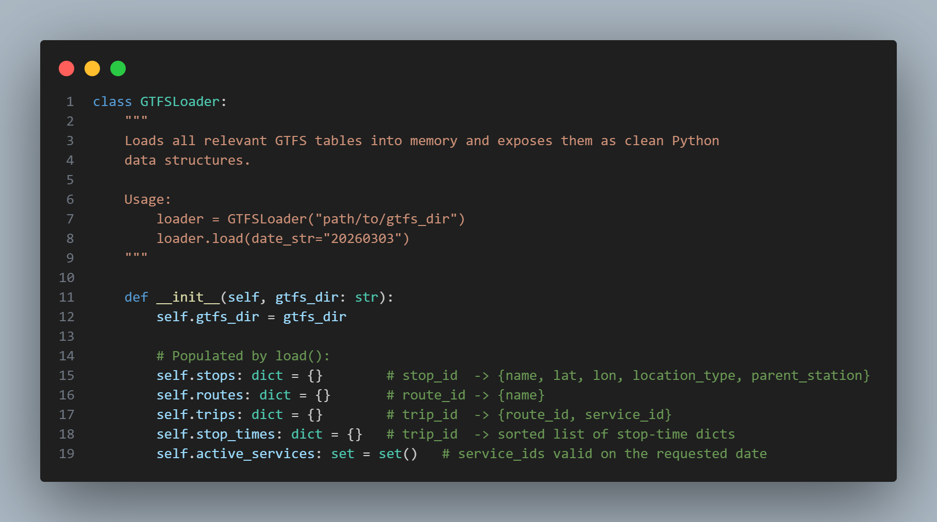
Each file has its own parser as each one has different attributes.
Example for the file stops.txt that represents the nodes of the graph:
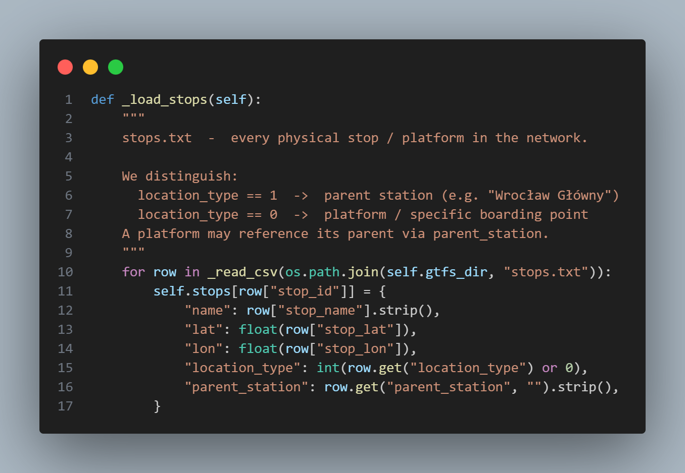
Once we have the data in dictionaries, we can start checking what we have by plotting the data into a map.
We need to create the program visualize.py
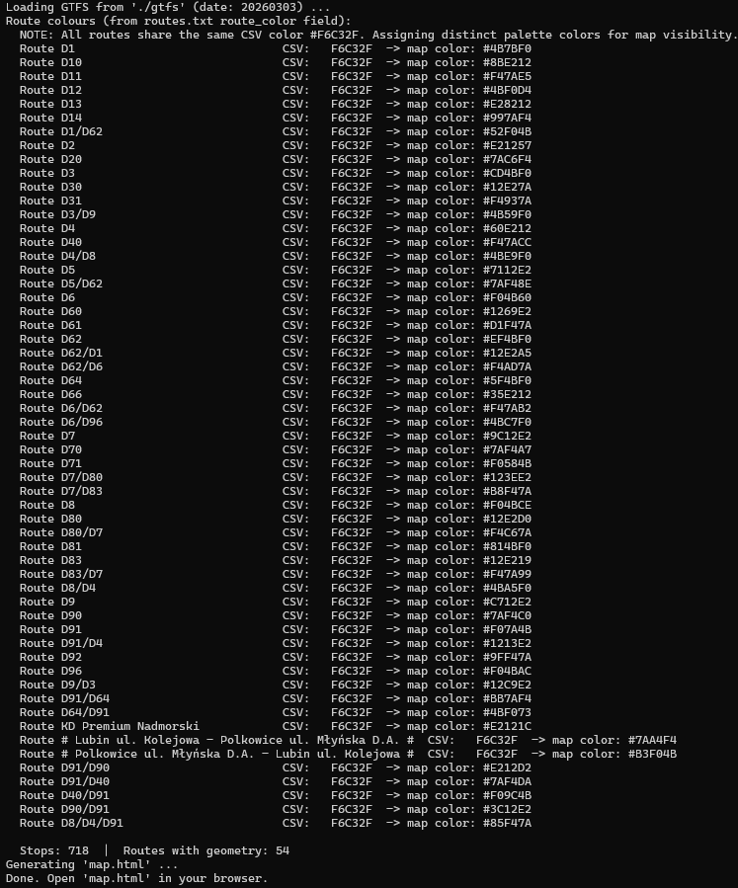
Thanks to the artificial intelligence for the coloring and styling of the html file and part of the comments in the code we can plot the stations (nodes) and trips (edges) into a map thanks to the coordinates provided in the data.
After running the command: python visualize.py
If all data is in its place, by default, the file map.html is created and added into the folder of the visualize.py file.
If you open it, all the station and lines will appear in a colorful way.
If you click in any station, you can check its name, id and also the trips/lines that pass through it.
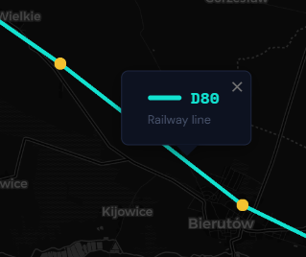
As well as clicking on any colorful line will pop up the railway code.
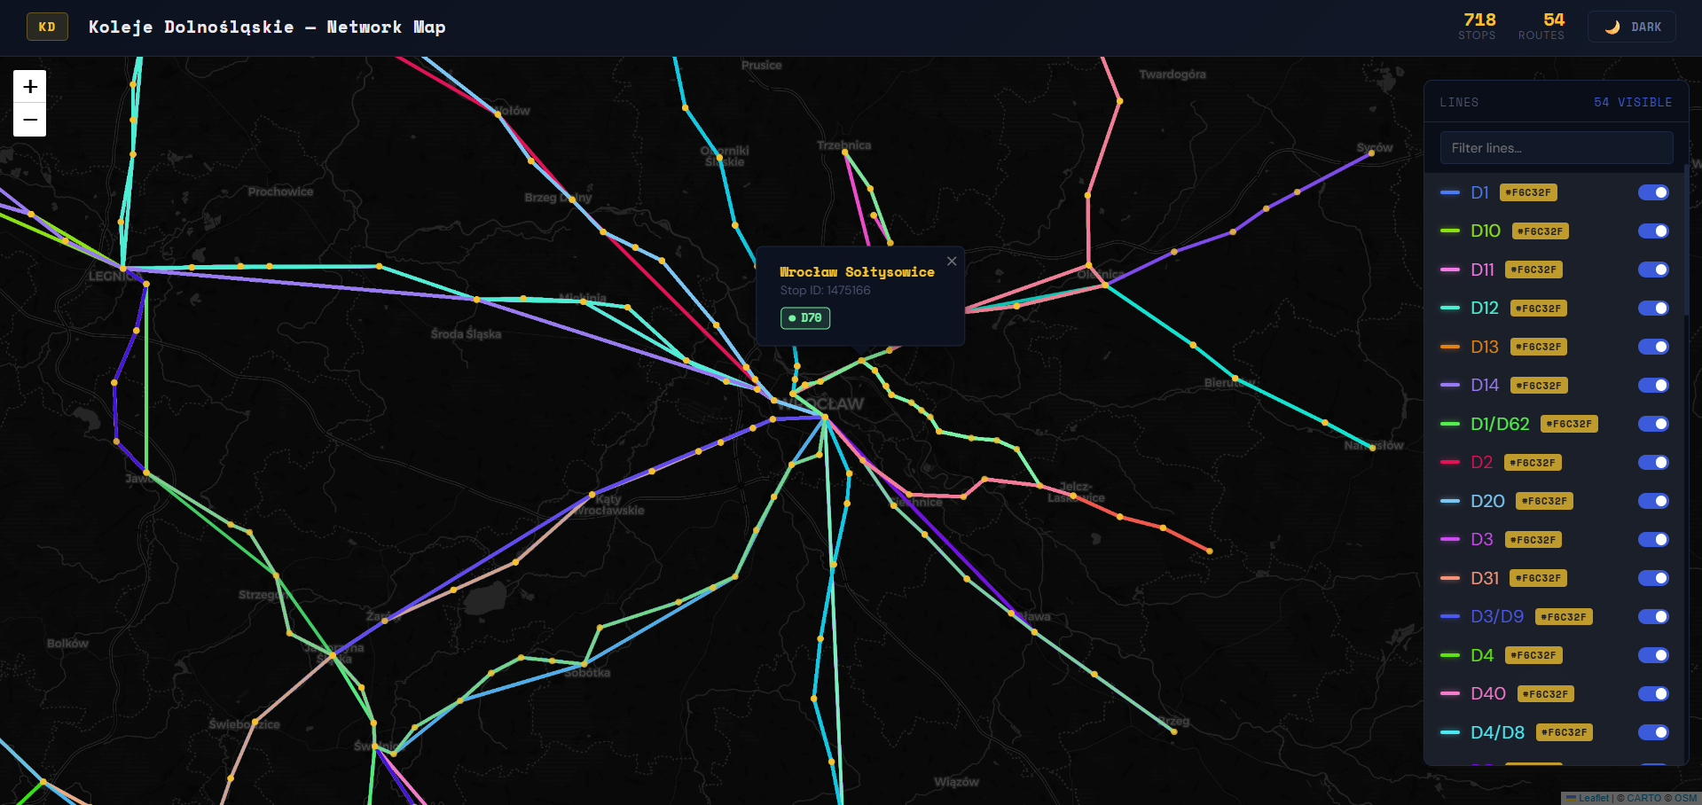

Searching algorithm as a cost function:
With the use of the provided GTFS dataset from Koleje Dolnośląskie, implement an algorithm searching for shortest paths between given stops A and B. As a cost function use (depending on the user’s decision) travel time from A to B or the number of transfers needed.
Application should accept input in form of 4 variables:
(a) the starting stop A
(b) the ending stop B
(c) optimization criterion: value t denotes travel time minimization, value p means minimization of the number of transfers
(d) start time
The solution should print out to the standard output in successive lines detailed path information including starting stop, ending stop, used line’s name, starting time, ending time, and on the standard error output the value of minimized criterion and time required for calculation of the shortest path.

Shortest path search from A to B using Dijkstra’s algorithm, based on travel time criterion (10 points):
We need to implement the dijkstra_time function.
Why Dijkstra works here?
Even though edges have varying costs (wait + ride), the effective edge cost (new_arrival - current_arrival) is always >= 0 when we require departure >= arrival.
This non-negativity is the only requirement for Dijkstra's correctness.
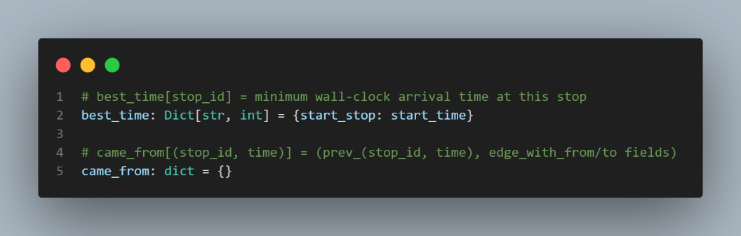
For making it work we need for each station to calculate the best time to arrive to that stop given a start_stop for that we store all reachable stops in a best_time dictionary and the previous best stop in the came_from dictionary.
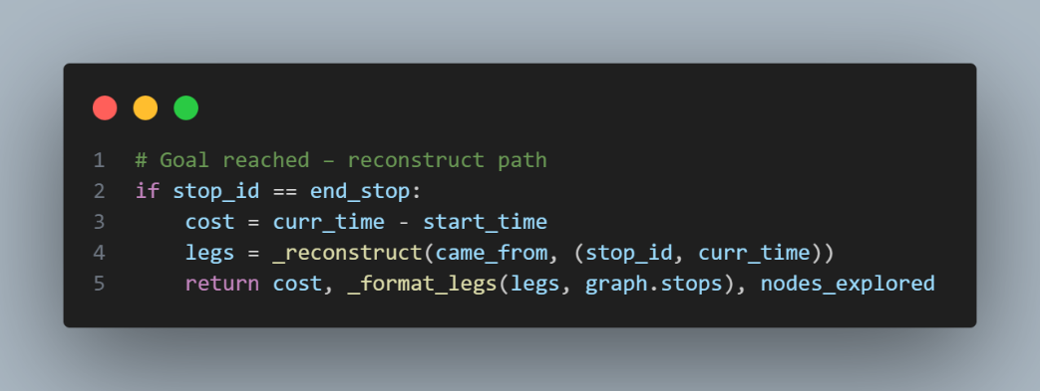
Given that variables, we need to start with the algorithm by creating a priority queue for selecting the “best” node for continuing with the algorithm.

We create the final case where the current stop is equal to the end stop:

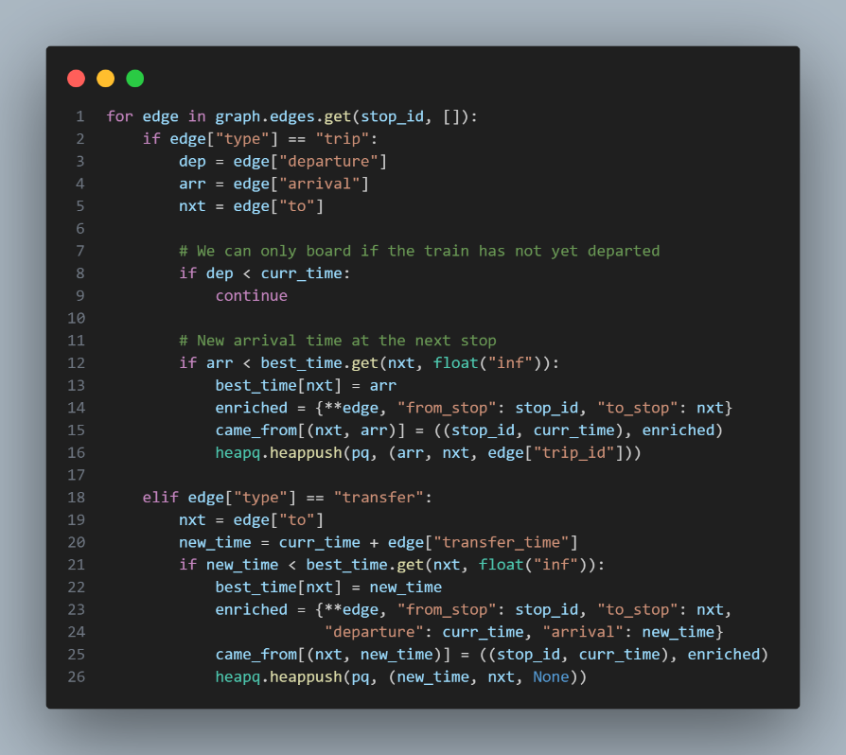
And the important part of the Dijkstra algorithm is inside a loop with the condition that there is an element available in the heap we check if it is solution, if its time is worse than the best time to that station, if not, we perform the check of every edge/trip from that station if the train has not departed yet, and add the next stations into the heap:
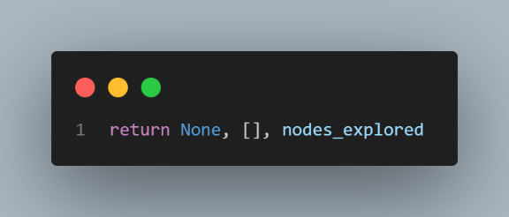
So, if no path is found then it is impossible to get there and we return an empty answer.

For checking that the algorithm works we can try it:
To run this part of task 1, we can run:
python task1.py <start_stop> <end_stop> <criterion> <start_time> --algo dijkstra
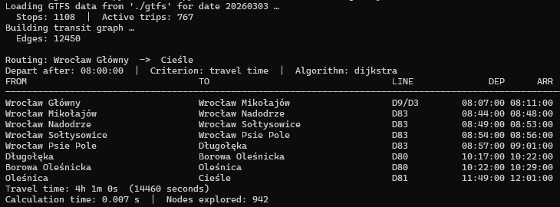
The command that I did as an example was: python task1.py 1474651 1474981 t 08:00 --algo dijkstra
We can manually check that the times are correct (in the trips.txt) and they are correct, let’s check with another algorithm to see if part A is the fastest part.

Shortest path search from A to B using A* algorithm, based on travel time criterion (25 points):
We need to implement the astar_time function, what heuristic was chosen?
$$h(n)=\frac{haversine_distance(n, goal)}{MAX_TRAIN_SPEED}$$
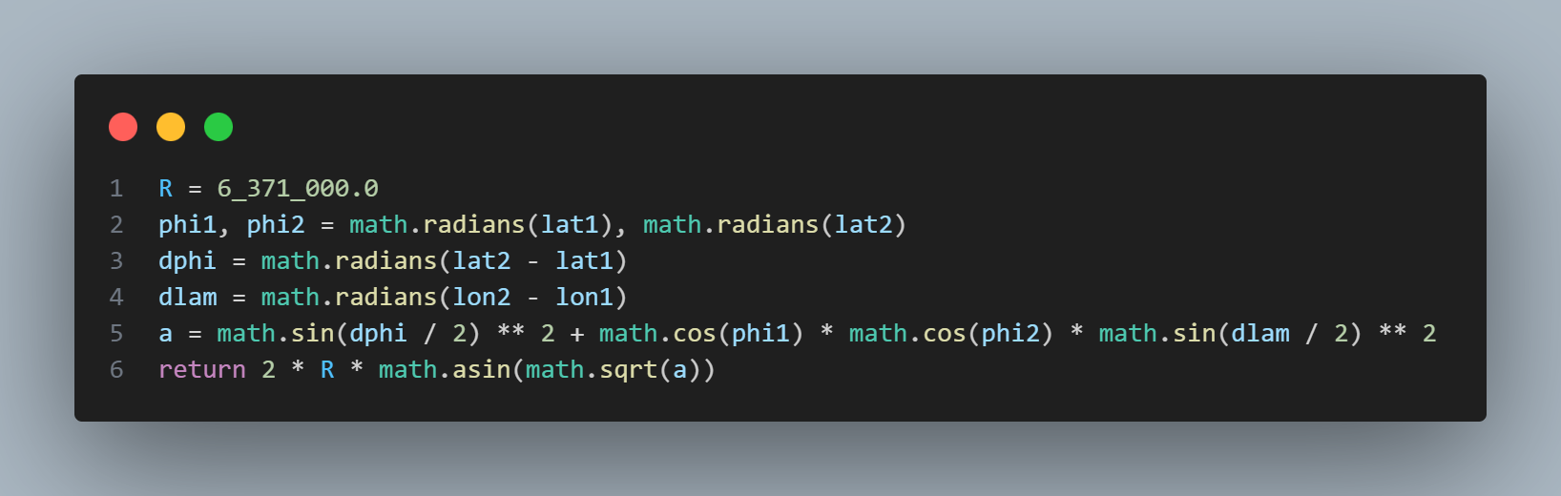
And why this heuristic improves the performance of the solution improving dijkstra’s time:
Dijkstra expands nodes in all directions uniformly. A* biases expansion towards the goal using the heuristic, so many stops in the wrong direction are never explored.
This dramatically reduces the number of nodes_explored.
Basically, instead of using from the heap the lowest time as in Dijkstra, we use the
$$f_{score}=elapsed time+heuristic remaining time$$
The code is exactly the same as in Dijkstra except for this parts:
The station extraction:
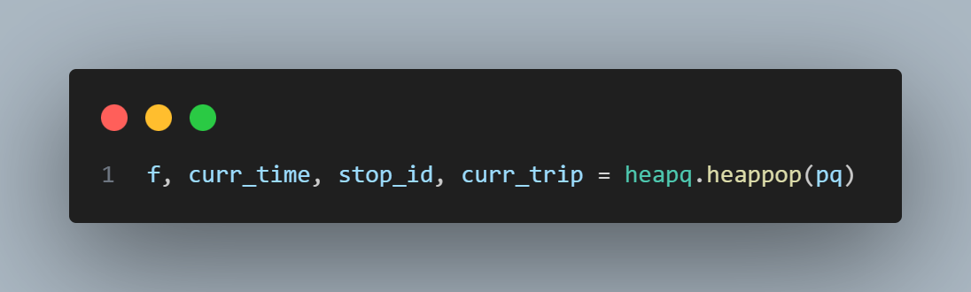
And the calculation in the push into the heap: 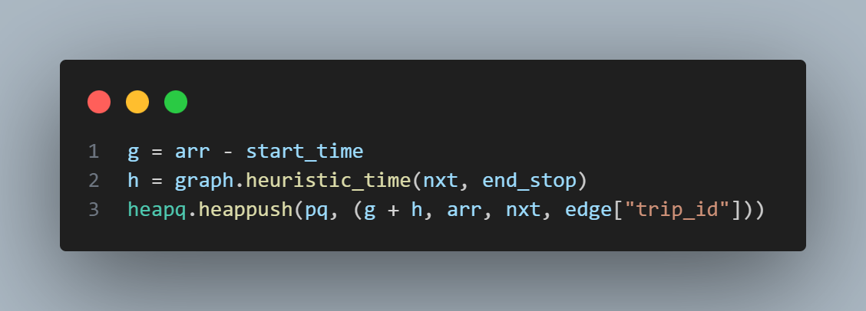
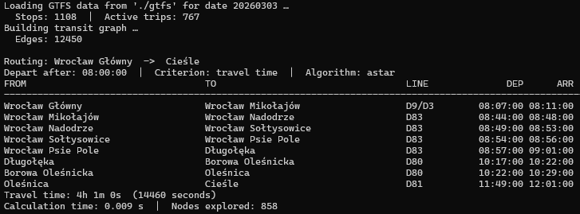
Once that heuristic is applied, we can run the command:
python task1.py <start_stop> <end_stop> <criterion> <start_time>
So we run it with the previous parameters: python task1.py 1474651 1474981 t 08:00

In this case as the nodes are too near, Dijkstra’s algorithm is better regarding the time it took, but the A* algorithm explored less nodes but with a larger time spent for each calculation of the heuristic value.

Shortest path search from A to B using A* algorithm, based on the number of transfers criterion (25 points):
We need to implement the astar_transfers function, what counts as a transfer?
Boarding the first train is free (no transfer). Every subsequent boarding of a *different* trip_id counts as +1 transfer. Walking between platforms of the same station does NOT add a transfer but does add waiting/walk time.
The selected heuristic as explained in the code is 0 for all nodes as it is simple and that a harder heuristic without a precomputation is hard to design.
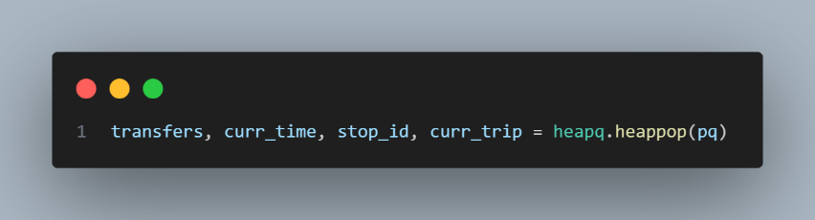
Now the heap has the transfers as first:

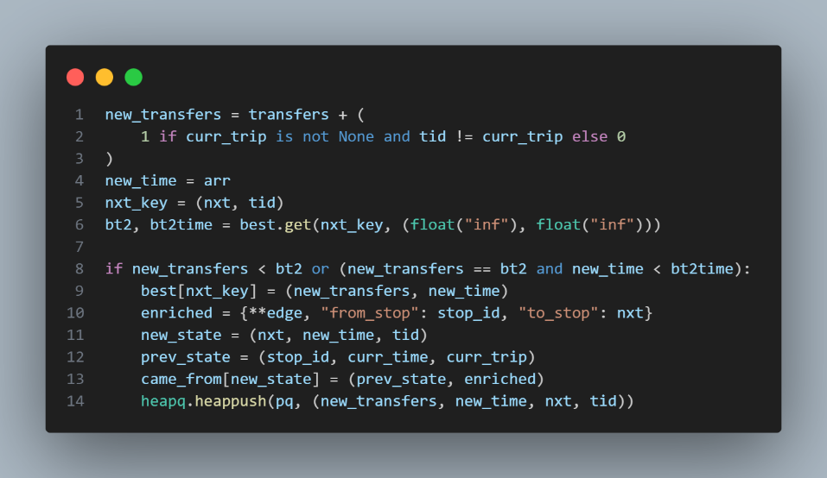
And the main logic:

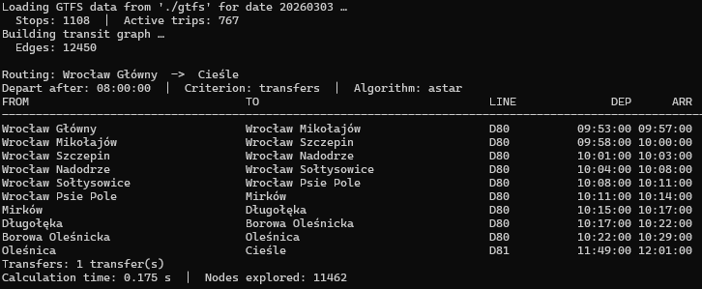
Once all is coded, we can perform the same search and check the differences:
python task1.py <start_stop> <end_stop> <criterion> <start_time>
So we run it with the previous parameters: python task1.py 1474651 1474981 p 08:00
As you can see the number of trains was reduced to just 2, it took more time (due to the heuristic) but found a 1 transfer route that is better for the user to avoid changing trains.

Modifications of A* algorithm from (b) or (c), allowing the reduction of computational time or improving quality of found solution (10 points):
As told in theory, we can use a Bidirectional search with A*, usually is not necessary as A* is efficient enough but just for the experiment, let’s do it.

I took inspiration from: https://github.com/ivanbgd/A-Star_Algorithm

The algorithm consists of 2 phases as the graph is time dependent:
Phase 1: Start the algorithm in both start and end and find a meeting point.
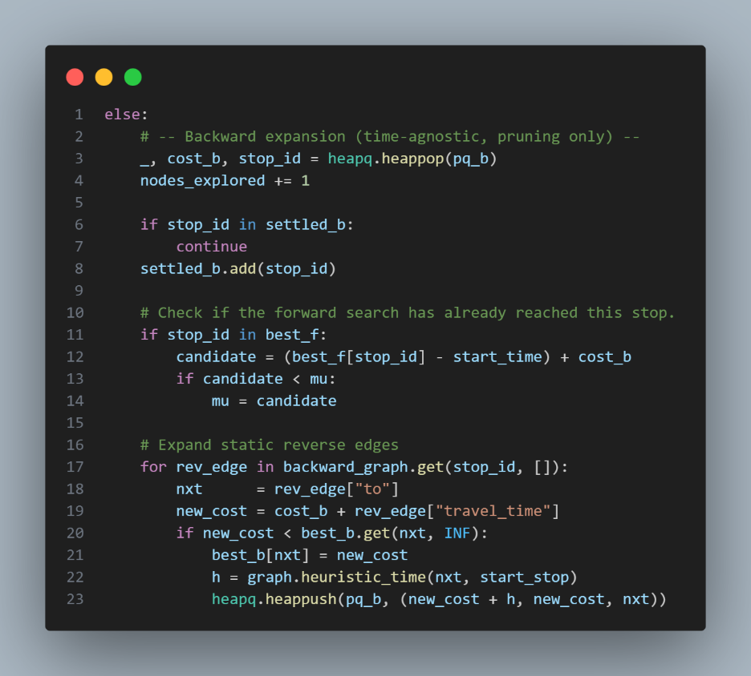
Divided into the backward expansion:
And the forward expansion:
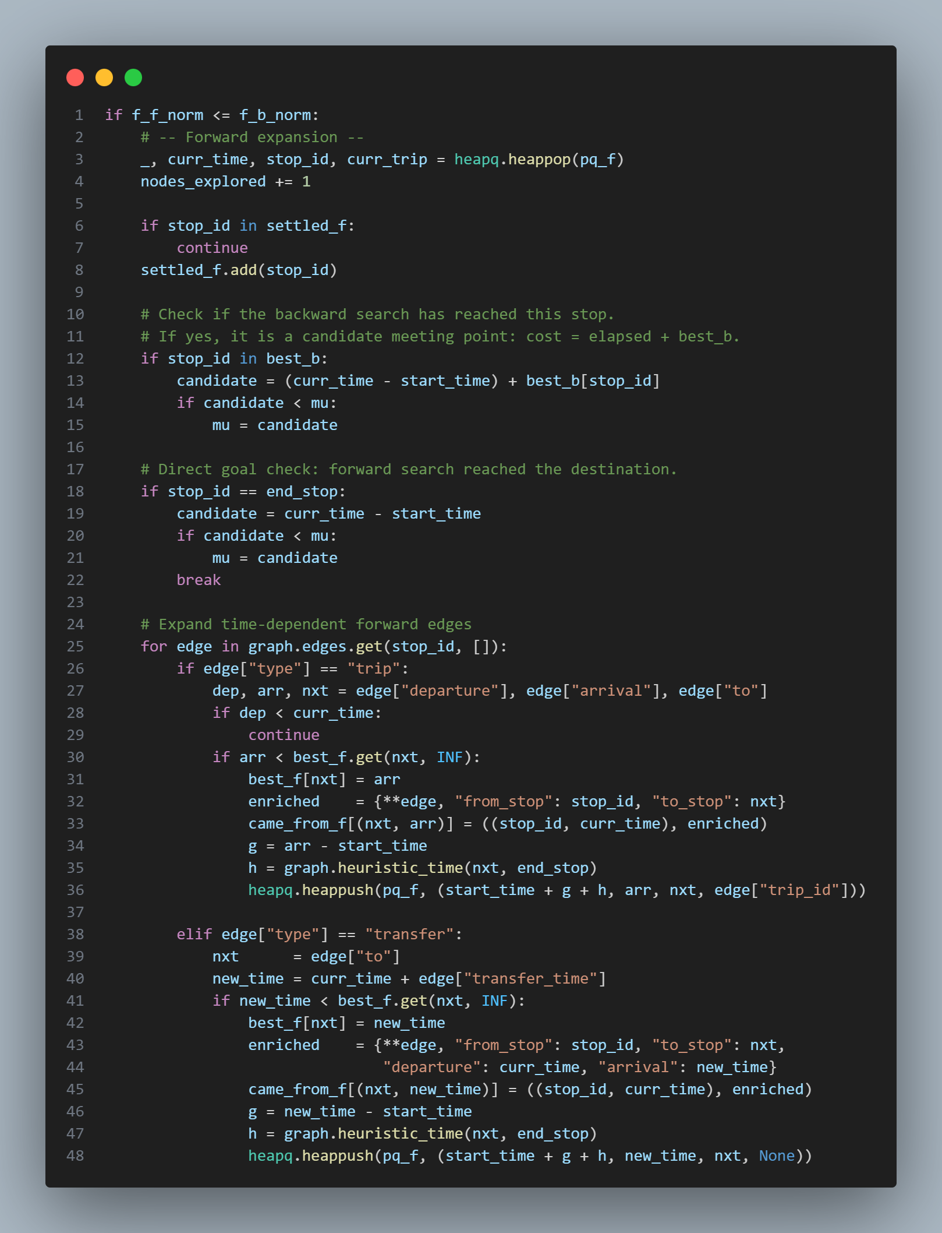
Phase 2: Once the algorithms meet, create another A* from the meeting point to the end to recalculate the times as the algorithm from the end to the meeting point couldn’t calculate the exact time as it did not have any time reference of the end time.
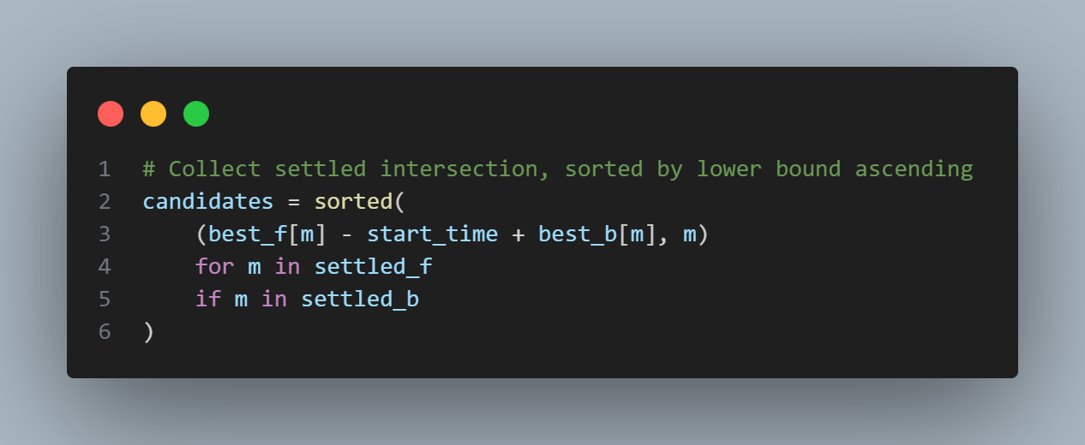
The problem that I had was that it was working but as phase 2 was not implemented the solution was not efficient, so after adding phase 2 with the MAX_PHASE2_TRIES the result was now perfect and node exploration efficient.
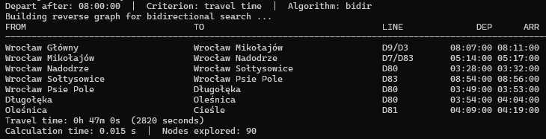
We can perform the same search and check the differences:
python task1.py <start_stop> <end_stop> <criterion> <start_time> --algo bidir
So we run it with the previous parameters: python task1.py 1474651 1474981 p 08:00 --algo bidir
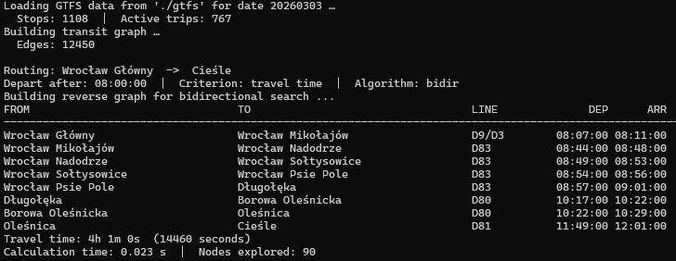
The nodes explored are drastically reduced from the normal A*, so we can consider it a better solution with that approach.

Several stops with the shortest path algorithm:
Using the provided GTFS dataset, implement the shortest path from a given stop A that visits all the stops given in a list L= A2, . . . , An, and returns back to A. As a cost function use (depending on the user’s decision) travel time from A to B or the number of transfers needed.
The application should accept input consisting of 4 variables:
(a) starting stop A
(b) list of stops to visit separated by a semicolon L
(c) optimization criterion: value t denotes travel time minimization, value p means minimization of the number of transfers
(d) starting time
The solution should print out to the standard output, in consecutive lines, the detailed path information including starting stop, ending stop, used line’s name, starting time, ending time, and on the standard error output the value of the minimized criterion and time required for calculation of the shortest path.

An algorithm searching for the shortest path between the nodes based on Tabu Search without bounding the size of T (10 points):
First, we need to understand a little bit what the Tabu Search is, here is a useful link: https://en.wikipedia.org/wiki/Tabu_search
We divide the code into 4 steps:
Stage 1: Calculating the shortest paths from every station to every station in the stops_list
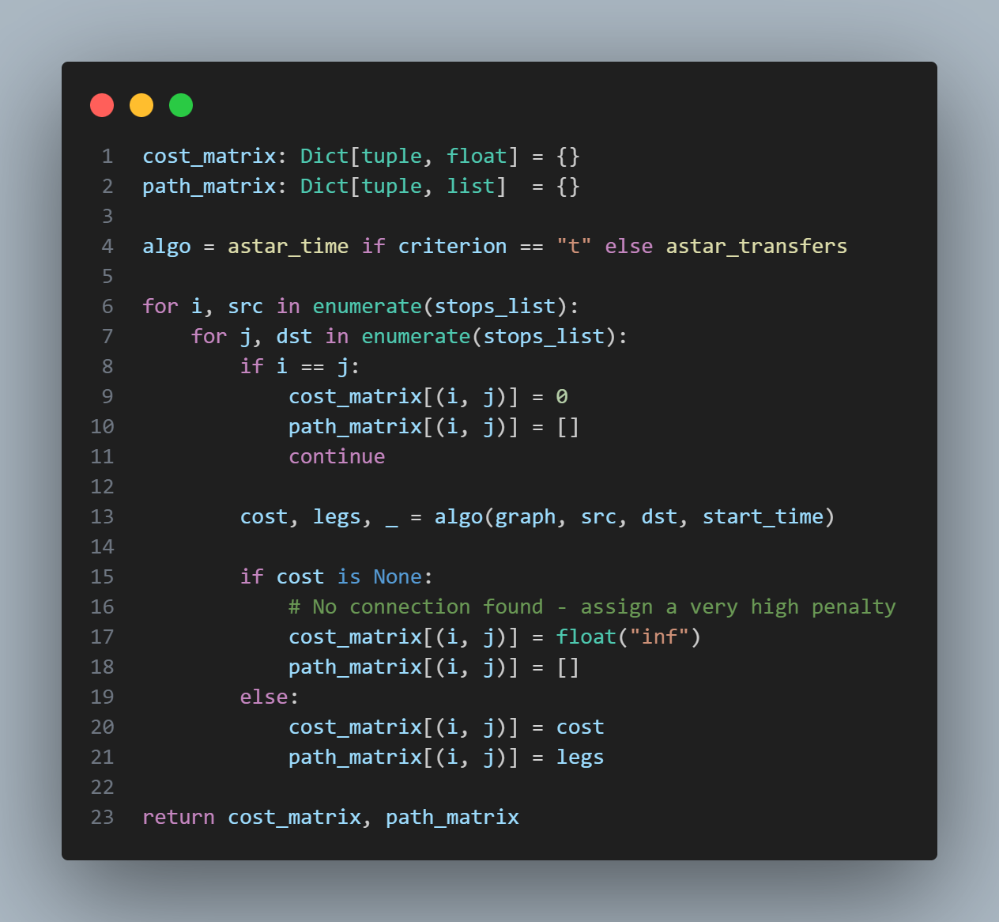
Stage 2: Applying the Tabu Search algorithm tabu_search
The algorithm steps are:
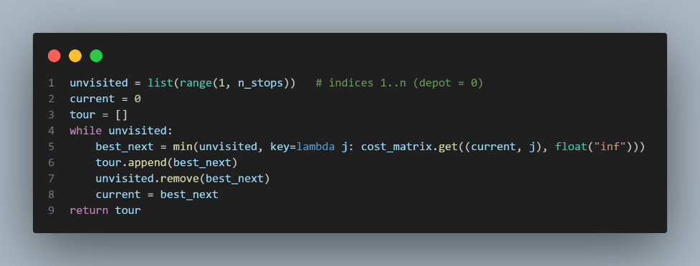
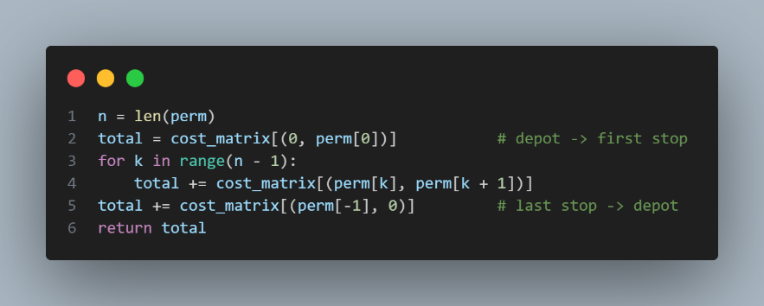
- Generate initial solution (nearest-neighbour). -> _nearest_neighbour_init(n_stops, cost_matrix) and _tour_cost(s, cost_matrix)

- s* = s, T = ∅.
- Repeat for step_limit iterations:
- Generate neighbourhood N(s) (all 2-opt swaps, or sample).
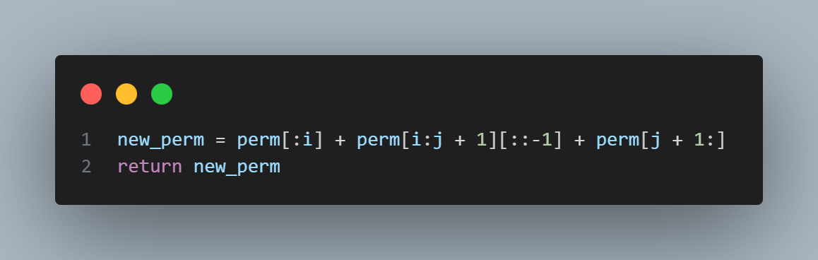
- Find best s' in N(s) - T (or s' in T if aspiration criterion met).
- Update T (FIFO, evict oldest if full).
- s = s'.
- If D(s) < D(s*): s* = s.
- Return s*.
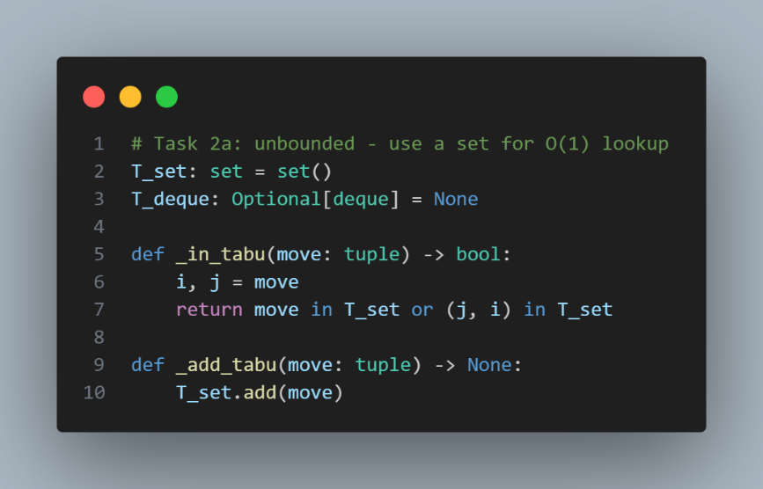
For an unbounded tabu list T, we use a set:
And finally, the main loop part of the code:
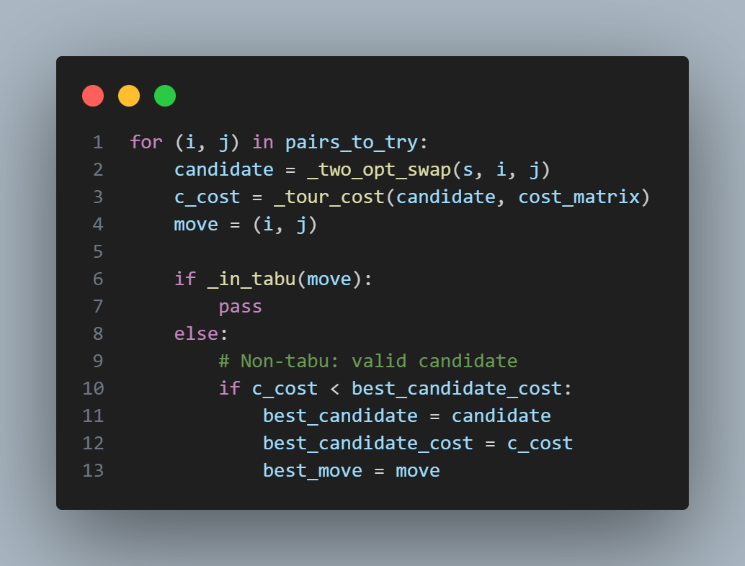
If we found a better candidate, we make it the best and continue with another iteration.

Modification of the algorithm (a) with a variable T size, based on the length of L, in order to minimize the cost function (5 points):
We can design that if the tabu_size is written we apply this approach, otherwise the unbounded one:
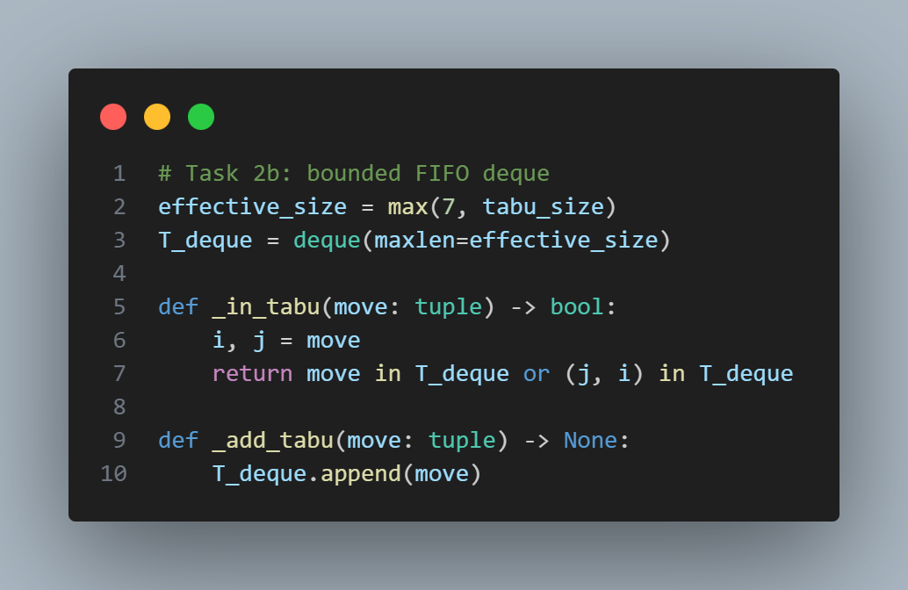
This FIFO of bounded size will discard the oldest entry if it reaches its full capacity, and as we only change the functions content, the rest of the code remains the same.
The algorithms are: Caesar / R

Modification of the algorithm (a) by adding Aspiration criterion, in order to minimize the cost function (5 points):
Just a simple piece of code can improve drastically the result:
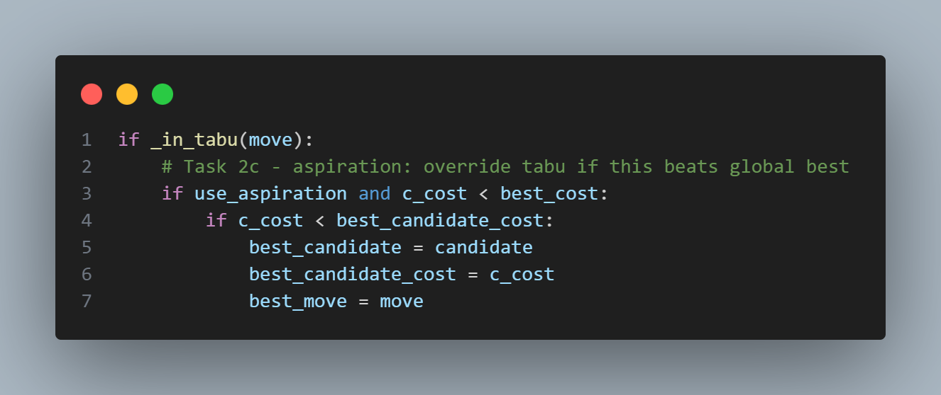
The aspiration prevents the tabu list from blocking genuine improvements. In it a tabu move is accepted anyway if the resulting tour is better than the globally best-known tour s*.

Modification of the algorithm (a) by adding a neighbor sampling strategy to minimize the cost function and reduce the computation time. (10 points):
For this part we need to create another input parameter to the tabu_search function called sampling and in the main loop of the tabu search we add:
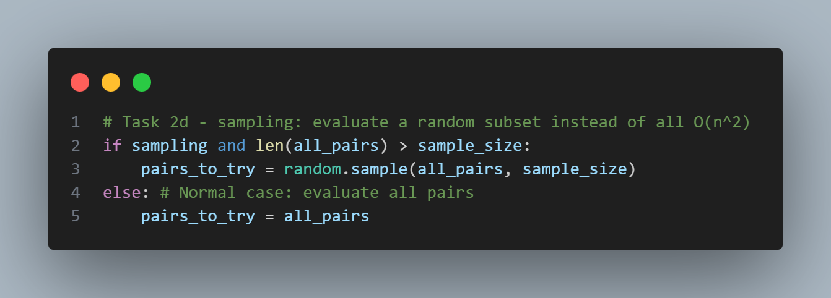
This improves performance time by taking random samples of neighbours instead of all to avoid spending too much time on each one.

After fixing a bug where the starting time was fixed once you reached a given destination and later about the pass of the day into the next stopped the algorithm from working.
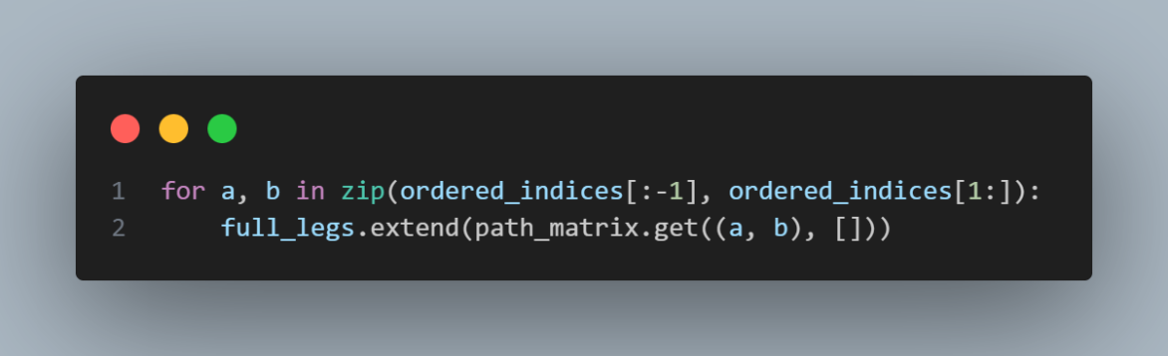
This was the error code:
And now the times are calculated fine.

We can try all the modes of the code with:
Part A: python task2.py "1474651" "1474843;1475162;1475133" t 08:00 --no-aspiration
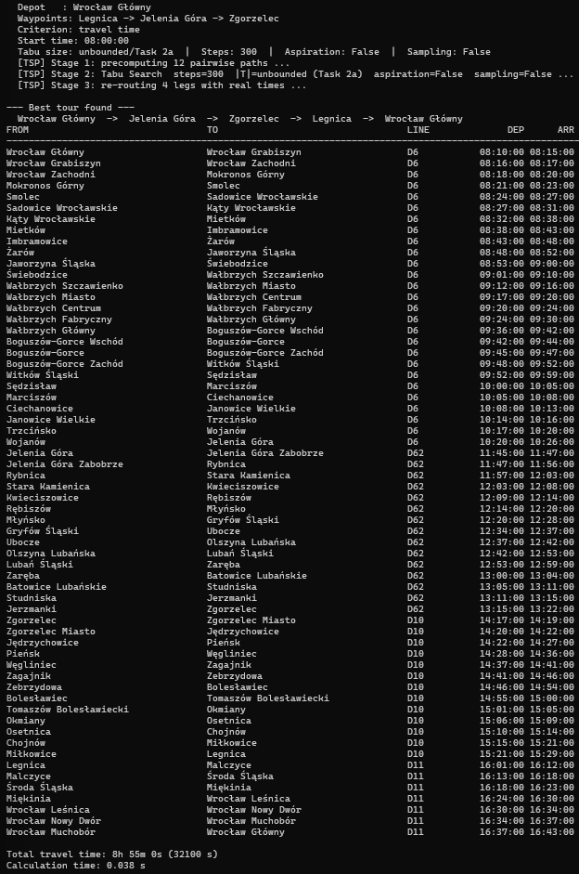
You can check that the Tabu size is unbounded with also aspiration and sampling off.
Part B: python task2.py "1474651" "1474843;1475162;1475133" t 08:00 --no-aspiration --tabu-size 5
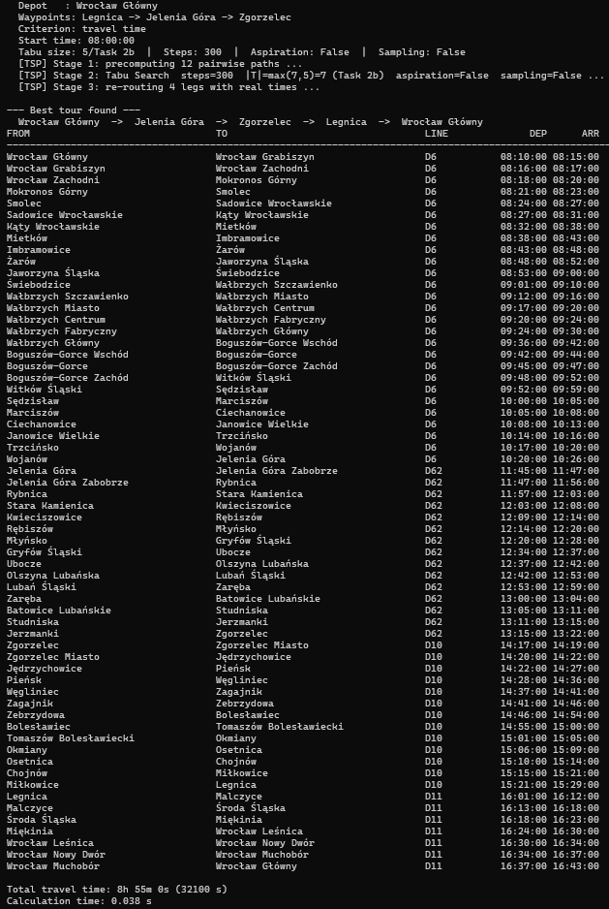
We can check that the best solution is the same and as the number of edges per node is low, the time is similar to the unbounded strategy (Part A).
Part C: python task2.py "1474651" "1474843;1475162;1475133" t 08:00
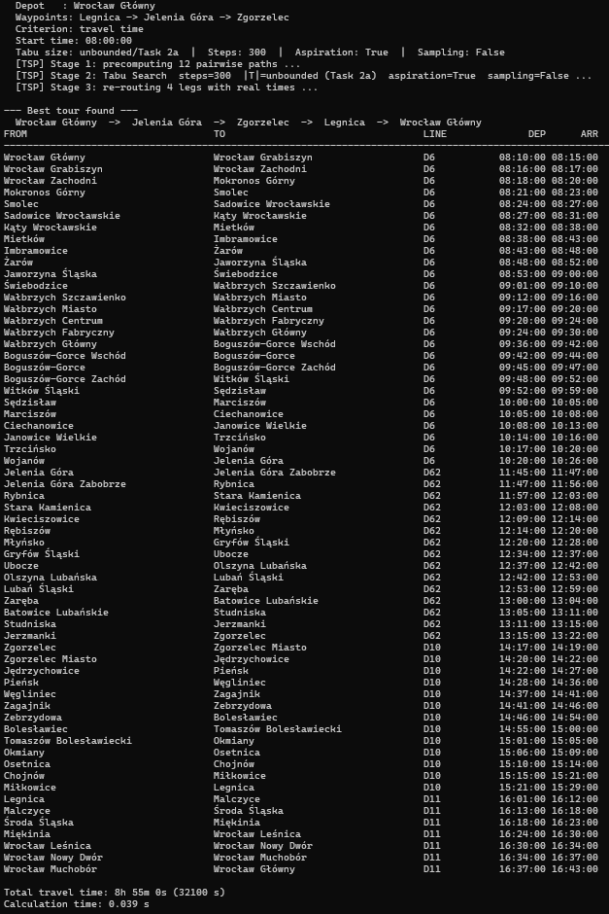
The code time execution is similar to the bounded tabu list in previous part (B).
Part D: python task2.py "1474651" "1474843;1475162;1475133;1475015;1475245" t 08:00 --sampling --sample-size 15 --steps 500
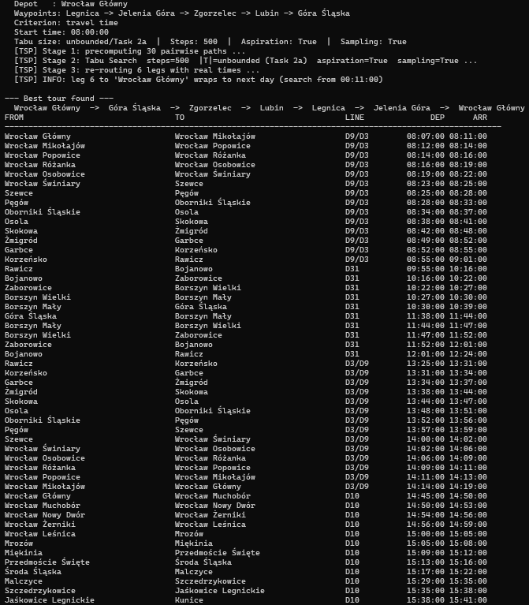
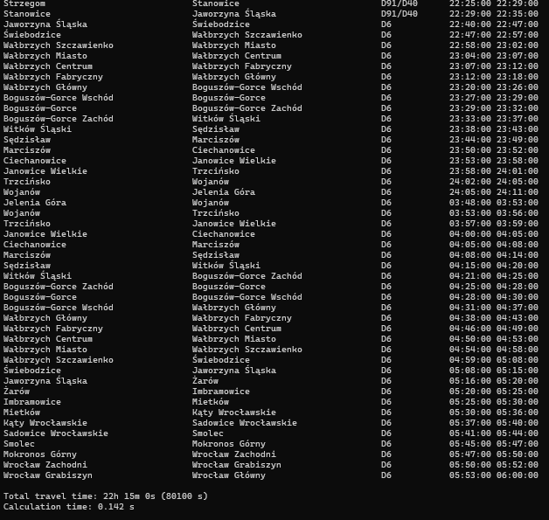
After a fix in the way that the program manages the pass of the day (> 23:59:59), we can finally see that the algorithm can handle several stops in a reasonable amount of time.

